**29-July-2024**

**Internship Day - 10 Report:**

**MySQL Installation Steps on Linux**

**What is a Database?**

A database is an organized collection of structured information or data, typically stored electronically in a computer system. Databases are managed by Database Management Systems (DBMS), which allow for efficient data storage, retrieval, and manipulation.

**Types of Databases:**

1. **Relational Databases**: Use structured query language (SQL) for defining and manipulating data. Data is stored in tables with predefined relationships (e.g., MySQL, PostgreSQL, Oracle).
2. **NoSQL Databases:** Designed for unstructured data and can store data in various formats (e.g., document-based, key-value pairs). Examples include MongoDB, Cassandra, and Redis.
3. **Object-oriented Databases**: Store data in the form of objects, similar to object-oriented programming (e.g., db4o, ObjectDB).
4. **Distributed Databases**: Data is distributed across multiple locations, which can be on the same network or geographically dispersed (e.g., Google Cloud Spanner).
5. **Cloud Databases:** Databases that run on cloud computing platforms, offering scalability and flexibility (e.g., Amazon RDS, Azure SQL Database).

**MySQL Overview:**

MySQL is an open-source relational database management system (RDBMS) that uses Structured Query Language (SQL) for accessing and managing data. It is widely used for web applications and is known for its reliability, performance, and ease of use. MySQL supports various storage engines, allowing for different data handling methods, and is often used in conjunction with PHP and Apache in web development.

**MySQL Installation Steps in Linux (Brief):**

1. **Update Package Index:**

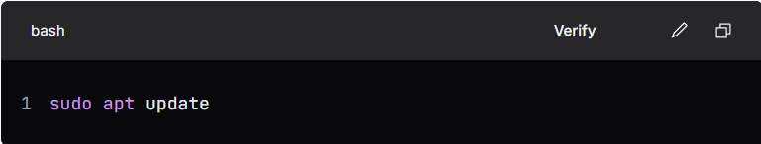

1. **Install MySQL Server:**

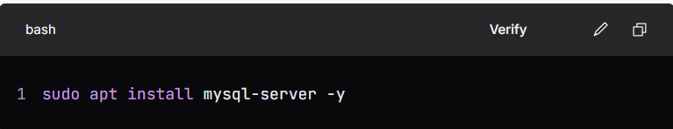

1. **Check MySQL Service Status:**

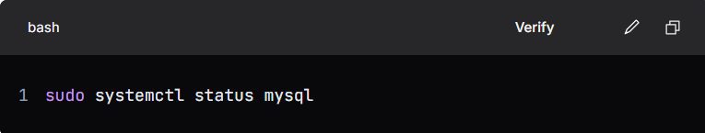

1. **Secure MySQL Installation:**

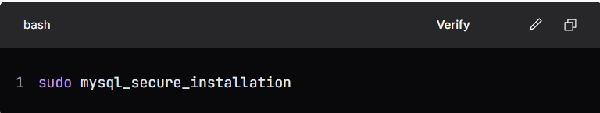

1. **Access MySQL Command Line:**

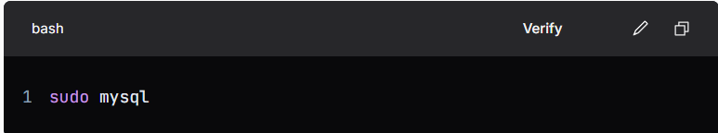

1. **Exit MySQL Command Line:**

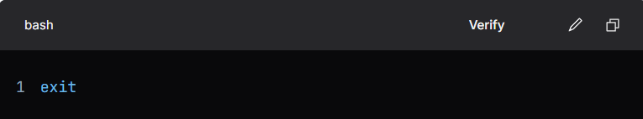

1. **Remove MySQL and Dependencies (if needed):**

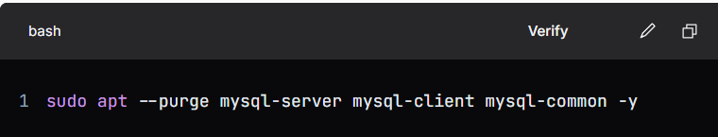

By following these steps, you can effectively install and manage MySQL on a Linux system.

**30-july-2024**

**Internship Day - 11 Report:**

**What is IIS Server?**

IIS (Internet Information Services) is a web server software created by Microsoft for use with the Windows operating system. It is designed to host and serve web applications and websites, providing a platform for developers to build, manage, and deploy web content. IIS supports various protocols, including HTTP, HTTPS, FTP, FTPS, and more, allowing for flexible and secure web hosting.

**Key Features of IIS:**

1. **Web Hosting:** IIS allows for the hosting of static websites (HTML, CSS, JavaScript) and dynamic web applications built using technologies such as ASP.NET.
2. **Security:** IIS includes built-in security features such as authentication, authorization, and SSL/TLS for secure data transmission.
3. **Scalability:** It can handle a large number of concurrent users and can be configured to scale with the needs of the application.
4. **Management Tools:** IIS provides a user-friendly management interface, allowing administrators to configure settings, monitor performance, and manage applications easily.
5. **Application Support:** IIS supports various application frameworks, including ASP.NET, PHP, and others, enabling developers to create a wide range of web applications.
6. **Logging and Diagnostics:** It offers robust logging capabilities for tracking user activity and diagnosing issues, helping maintain optimal performance.
7. **Extensibility:** IIS can be extended with modules and plugins, allowing for additional functionalities and customizations based on specific needs.

Overall, IIS is a powerful and versatile web server solution widely used in enterprise environments for hosting websites and applications.

**Introduction od RDP?**

A remote desktop client is a software application that allows users to connect to and control another computer over a network or the internet. This enables users to access their desktop environment, applications, and files from a different location, as if they were sitting in front of the remote machine.

**Why We use Remote Desktop Clients?**

Remote desktop clients are utilized for various reasons, including:

1. **Remote Access:** They allow users to access their work or home computers from anywhere, facilitating remote work and flexibility.
2. **Technical Support:** IT professionals can use remote desktop clients to troubleshoot and resolve issues on users' machines without needing to be physically present.
3. **Resource Management:** Users can access applications and files stored on a remote computer, enabling them to utilize resources that may not be available on their local devices.
4. **Collaboration:** Remote desktop clients can facilitate collaboration among team members by allowing them to share screens and work together on projects in real-time.
5. **Security:** Many remote desktop solutions offer secure connections, ensuring that data transmitted between the client and the remote machine is encrypted and protected from unauthorized access.
6. **Cost-Effectiveness**: Organizations can reduce costs by allowing employees to work from

home or other locations without needing additional hardware or software.

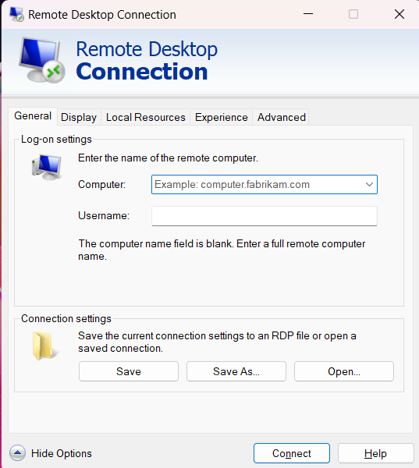

**Steps to Backup and Restore Data Using AWS Instance with Remote Desktop Connection**

**1. Set Up Remote Desktop Connection**

* Connect to your AWS Windows instance using Remote Desktop Protocol (RDP).

**2. Prepare and Attach a New Volume**

* Go to AWS Console → EC2 → Volumes.
* Create a new volume with a desired size in the same Availability Zone as the instance.
* Attach the volume to your instance, specifying an available device name.

**3. Initialize the New Volume in Windows**

* Open the Remote Desktop window for your instance.
* Go to This PC → Manage or search for Server Manager.
* In Server Manager, go to File and Storage Services → Disks.
* Find the new volume (it should be offline initially); set it to Online.

**4. Format the Volume and Allocate Space**

* Create a new volume, allocate space, and complete the setup.
* Close Server Manager and verify the new volume in This PC.
* Create a folder on the new volume (e.g., on D: drive, not C:).

**5. Create a Snapshot of the Volume**

* In the AWS Console → EC2→ Volumes, select the new volume.
* Create a snapshot to back up the volume’s current state.

**6. Detach the New Volume**

* Detach the volume from the instance (e.g., 100GB volume that was attached).

**7. Restore Data from Snapshot on a New Instance**

* In AWS Console → Snapshots, create a new volume from the snapshot.
* Attach this volume to the new instance.

**8. Verify Data on the New Instance**

* Open Remote Desktop on the new instance.
* Go to This PC → Server Manager → File and Storage Services→ Disks.
* Confirm the restored data is visible and accessible on the new instance.

**31-july-2024**

**Internship Day - 12 Report:**

**What is xfreedp?**

**xfreerdp** is an open-source command-line client for the **Remote Desktop Protocol (RDP)** on Linux. It allows users to connect to and control Windows systems from Linux machines. It is especially useful for remote access in headless or lightweight Linux setups, without needing a full graphical desktop client.

**Why Use xfreerdp in Linux?**

* **Cross-platform access**: Provides Linux users the ability to access and manage Windows machines.
* **Lightweight**: Command-line-based, consuming fewer resources than graphical clients.
* **Customizable**: Supports various options for configuring resolution, sound, and clipboard sharing.

**Installation Steps**

  
After installation, you can use xfreerdp to initiate an RDP connection. For example:



### Steps to Launch a Windows Instance in AWS:

1. **Log in to AWS Console**: Go to the [AWS Management Console](https://aws.amazon.com/console/) and sign in.
2. **Navigate to EC2 Service**: In the AWS Console, go to **Services** → **EC2**.
3. **Launch Instance**: Click on **Launch Instances** to start the setup process.
4. **Choose an Amazon Machine Image (AMI)**: Select a Windows Server AMI (e.g., Windows Server 2019 Base).
5. **Select Instance Type**: Choose an instance type (e.g., t2.micro for free tier or higher based on needs).
6. **Configure Instance Details**: Adjust settings like number of instances, network, and IAM role (leave as default if unsure).
7. **Add Storage**: Set the storage size and type for the root volume or add extra volumes if needed.
8. **Configure Security Group**: Add a rule to allow **RDP (port 3389)** for remote access; restrict IP access if desired for security.
9. **Review and Launch**: Review settings and click **Launch**.
10. **Create or Select a Key Pair**: Choose or create a key pair for instance access, and download the key file (.pem).
11. **Launch the Instance**: Click **Launch Instances** to start it.
12. **Connect to the Instance**: After it's running, click **Connect** → **RDP Client** → **Get Password** (using the .pem file) to connect via Remote Desktop.

**Steps to Connect to an AWS Windows Instance Using xfreerdp on Linux:**

To connect to an AWS Windows instance from Linux using **xfreerdp**, follow these steps:

1. **Retrieve the Instance's Public IP and Password**:
   * Get the **Public IP** of your instance from the **EC2 Console**.
   * Decrypt the instance password using the **.pem** key.
2. **Connect Using xfreerdp**:

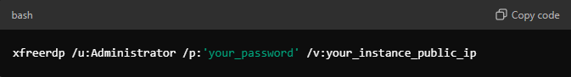

**1-Aug-2024**

**Internship Day - 13 Report:**

**Step-by-Step Guide for XAMPP Installation, HTML File Upload, and Database Access**

**1. XAMPP Installation**

* Download the XAMPP installer from the Apache Friends website.
* Run the installer and follow the prompts, selecting components (Apache, MySQL, PHP) and choosing the installation directory (e.g., C:\xampp).
* Complete the installation by clicking “Next” until finished.

**2. Setting Up IIS Server (Optional)**

* Open Server Manager, click on "Add roles and features," and proceed with the wizard.
* Select "Web Server (IIS)" under Server Roles and complete the installation process.

**3. Uploading HTML File**

* Open Microsoft Edge to access your server.
* Extract your HTML file.
* Copy the extracted files to C:\inetpub\wwwroot (for IIS) or C:\xampp\htdocs (for XAMPP).
* Obtain your server's IP address from the instance settings.

**4. Configuring Apache in XAMPP**

* Install Visual Studio Code if not already installed.
* Navigate to C:\xampp\apache\conf\httpd.conf and open it in VS Code.
* Modify line 285 (or similar) to change the DocumentRoot to your project folder.

**5. Accessing MySQL (MariaDB)**

**Method 1 (Command Line):**

* Open Command Prompt: cmd
* Navigate to MySQL directory: cd C:\xampp\mysql\bin
* Connect to MySQL: MySQL.exe -uroot -p (Press Enter)

**Method 2 (XAMPP Shell):**

* Open XAMPP Control Panel and click on “Shell.”
* Type: mysql -uroot -p (Press Enter)

**Method 3 (Direct Access):**

* Navigate to C:\xampp\mysql\bin in Command Prompt.
* Run: MySQL.exe -uroot -p (Press Enter)

**Method 4 (phpMyAdmin):**

* Open XAMPP Control Panel.
* Click on “Admin” next to MySQL to access phpMyAdmin.

**6. Creating and Accessing a Registration Form**

* Create a new file named index.php in the C:\xampp\htdocs directory.
* Add the following HTML and PHP code to index.php:

<!DOCTYPE html>

<html lang="en">

<head>

<meta charset="UTF-8">

<meta name="viewport" content="width=device-width, initial-scale=1.0">

<title>Registration Form</title>

<style>

body { font-family: Arial, sans-serif; }

form { margin-bottom: 20px; }

input { margin: 5px 0; }

</style>

</head>

<body>

<h2>Registration Form</h2>

<form method="POST">

Name: <input type="text" name="name" required><br>

Email: <input type="email" name="email" required><br>

Mobile: <input type="text" name="mobile" required><br>

<input type="submit" value="Submit">

</form>

<?php

if ($_SERVER["REQUEST_METHOD"] == "POST") {

$conn = new mysqli("localhost", "root", "", "your_database_name");

if ($conn->connect_error) {

die("Connection failed: " . $conn->connect_error);

}

$name = $_POST['name'];

$email = $_POST['email'];

$mobile = $_POST['mobile'];

$sql = "INSERT INTO users (name, email, mobile) VALUES ('$name', '$email', '$mobile')";

if ($conn->query($sql) === TRUE) {

echo "New record created successfully";

} else {

echo "Error: " . $sql . "<br>" . $conn->error;

}

$conn->close();

}

?>

<h3>Registered Users:</h3>

<ul>

<?php

$conn = new mysqli("localhost", "root", "", "your_database_name");

$result = $conn->query("SELECT name, email, mobile FROM users");

while ($row = $result->fetch_assoc()) {

echo "<li>{$row['name']} - {$row['email']} - {$row['mobile']}</li>";

}

$conn->close();

?>

</ul>

</body>

</html>

**7. Testing the Setup**

* Open your web browser and navigate to http://localhost/index.php to access the registration form.
* Fill in the form and submit to test

**2-Aug-2024**

**Internship Day - 14 Report:**

**Step-by-Step Guide for XAMPP Installation and Creating a Registration Form**

**1. Create a New Windows Instance**

Set up a new Windows instance on your preferred cloud platform or local machine.

**2. Install XAMPP**

* Download the XAMPP installer from the Apache Friends website and run it.

**3. Save Template in htdocs**

* During installation, specify the installation directory (e.g., C:\xampp) and ensure to save your project files in the htdocs folder (e.g., C:\xampp\htdocs).

**4. Create index.php for Registration Form**

* In the C:\xampp\htdocs directory, create a new file named index.php.

**5. Add HTML and PHP Code to index.php**

* Insert the following code into index.php to create a registration form that captures name, email, and mobile number, and displays the submitted data:

**6. Disable Windows Firewall Defender**

* Open the Run dialog (Windows + R), type Firewall.cpl, and press Enter to open Windows Firewall settings.
* Turn off Windows Defender Firewall for both private and public networks.

**7. Access Localhost**

* Open a web browser and navigate to http://localhost/index.php to access your registration form.